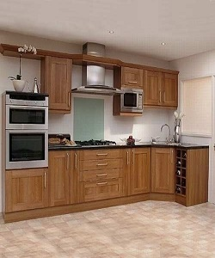

Modern Kitchen Cabinet

$248.36

Availability: In stock

Description

Modular kitchen wood cabinet. . Full assembly instructions are included in the box, certified for the highest quality.